Name: Wong Chee Kin

Matrik No.: 279592

**Object-oriented example:**

Triangle Class

Scalene

Equilateral

Isosceles

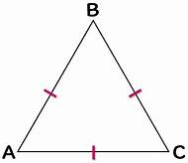v 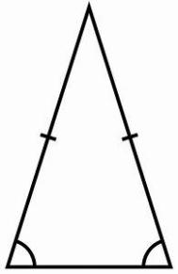 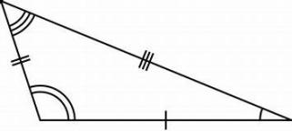

**States**

- 2 same internal angles

- 2 same equal length

**Behaviours**

- can cut into 2

**States**

- 3 different internal angles

- 3 non-equal length

**Behaviours**

- can cut into 2

**States**

- 3 same internal angles

- 3 same equal length

**Behaviours**

- can cut into 2

**States:** internal angles, length

Car Class

Audi

Honda

Toyota

  

**States**

- Orange

- Honda Civic

- Medium size

**Behaviours**

- Move fast

**-** Can stop

**States**

- Red

- Audi A6

- Medium size

**Behaviours**

- Move fast

**-** Can stop

**States**

- Blue

- Toyota C-HR

- Large size

**Behaviours**

- Move fast

**-** Can stop

**States:** Colour, model, boot space

Phone Class

Cell Phones

Corded Phones

 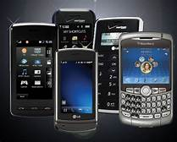

**States**

- Long-distance communication

- Not convenient

- Lower cost

- 1 function

**Behaviours**

**-** Call

**States**

- Long-distance communication

- Convenient

- Higher cost

- More than 1 function

**Behaviours**

**-** Call

- Send masseges

- Play

**States:** communication distance, convenient, cost, function

Shape Class

Rectangle

Triangle

Circle

**States**

- Length, Width

- Area = Length*Width

- Perimeter = a+b+c+d

- Green

**Behaviours**

**-** Can cut into 2 or more

- Can change to other shape

**States**

- Length, Width

- Area = Length*Width/2

- Perimeter = a + b + c

- Yellow

**Behaviours**

**-** Can cut into 2 or more

- Can change to other shape

**States**

- Radius

- Area = ℼr²

- Perimeter = 2ℼr

- Blue

**Behaviours**

**-** Can cut into 2 or more

- Can change to other shape

**States:** unit, area, perimeter, colour

Human Class

Female

Male

 

**States**

- Mom

- Daughter

- Student

- Employee

- Wife

**Behaviours**

- Eat

- Study

- Work

- Cheat

**States:** parent, child, status

**States**

- Dad

- Son

- Student

- Employee

- Husband

**Behaviours**

- Eat

- Study

- Work

- Cheat